SKAMpede 2022 Access Guide

# Overview

This document is a guide for Theatre SKAM audience members at SKAMpede to understand the accessibility measures being taken at this year's SKAMpede festival. If there are any questions or concerns, please contact Hannah Mariko Bell (She/Her) at [hannahb@skam.ca](mailto:hannahb@skam.ca).

This guide format was created by Navarra Houldin (She/Her).

# Index

**Overview** **1**

**Index** **1**

**ASL Interpreted Performances** **3**

Information about the ASL Interpreted Tours: 3

**Trigger Warnings and Content Notes** **4**

What is the difference between a Trigger Warning and Content Note? 4

Selkirk Tour Trigger Warnings and Content Notes 5

Baobab - Création multidisciplinaire - ENTROPIC FOGS 5

Fear No Opera - Breathe in the Beauty 5

Extended Space Theatre - BIAS 5

Reverse Puppet Productions - “When Everything Goes To Hell, I’ll Meet You At Our Spot” 5

Central Tour Trigger Warnings and Content Notes 5

Atomic Vaudeville- Hello Again 5

Embrace Arts Foundation - articulate 5

Traverse Arts Theatre - to be them/to be us 6

Katie Cassidy - funki fungi 6

Songhees Tour Trigger Warnings and Content Notes 6

Tara Rajah and Kiera Radosevic - Environmental Vibrations 6

Accompany Theatre - Deep End 6

SNAFU - Not Enough Sunscreen in the World 6

HUB Show Trigger Warnings and Content Notes 6

Reneltta Arluk 6

Lekwungen Traditional Dancers 6

**Trail Information** **7**

Trail Details 7

Selkirk Tour Trail Info 8

Baobab - Création multidisciplinaire - ENTROPIC FOGS 9

Fear No Opera - Breathe in the Beauty 9

Extended Space Theatre - BIAS 9

Reverse Puppet Productions - “When Everything Goes To Hell, I’ll Meet You At Our Spot” 9

Central Tour Trail Info 10

Atomic Vaudeville- Hello Again 11

Embrace Arts Foundation - articulate 11

Traverse Arts Theatre - to be them/to be us 11

Katie Cassidy - funki fungi 11

Songhees Tour Trail Info 12

Tara Rajah and Kiera Radosevic - Environmental Vibrations 13

Accompany Theatre - Deep End 13

SNAFU - Not Enough Sunscreen in the World 13

HUB Information 13

# 

# ASL Interpreted Performances

ASL (American Sign Language) Interpreted performances are a way of making shows accessible to patrons who are Deaf or hard of hearing. The ASL Interpreter stands to the side of the stage to interpret the spoken (or sung) parts of a performance. Theatre SKAM is fortunate to have a partnership with Island Deaf and Hard of Hearing, who has sponsored our ASL Interpreter.

## *Information about* the ASL Interpreted Tours*:*

* Saturday, July 9th 1:20 PM Selkirk Tour
* Saturday, July 9th 3:00 PM Central Tour
* Saturday July 9th, 4:40 PM Songhees Tour

# Trigger Warnings and Content Notes

The Trigger Warnings and Content Notes will be displayed on the Theatre SKAM website for patrons to access before the festival and available at the box office at each tour launch point. Trigger Warnings and Content Notes are important for patrons because we want to take care of our audiences and make sure they can make a properly informed decision.

"Warnings are about giving an audience the appropriate information needed to make a choice about what they want to be exposed to."

- [Responsible Theatremaking](https://howlround.com/responsible-theatremaking)

When audience members register/buy tickets, it's their form of giving consent and if they're not given the full information, they are unable to give their full consent to what they are seeing.

## What is the difference between a Trigger Warning and Content Note?

**Trigger Warnings (TW):** Trigger Warnings are used to prevent exposing patrons with past trauma to something that might incite a physical and/or mental reaction e.g., sexual violence. These warnings are also used for audience members who have medical conditions that can cause physical reactions.

**Content Notes (CN):** Content Notes inform the viewer of potentially distressing material E.g., blood or nudity.

### Selkirk Tour Trigger Warnings and Content Notes

#### Baobab - Création multidisciplinaire - *ENTROPIC FOGS*

* + TW/CN: N/A

#### Fear No Opera - *Breathe in the Beauty*

* + TW/CN: N/A

#### Extended Space Theatre - *BIAS*

* + TW: N/A
  + CN: Sexual content (innuendos), swearing/cursing

#### Reverse Puppet Productions - *“When Everything Goes To Hell, I’ll Meet You At Our Spot”*

* + TW: Discussions and depiction of death (apocalyptic context)
  + CN: Swearing/cursing, yelling throughout play (raised tones, no screaming)

### Central Tour Trigger Warnings and Content Notes

#### Atomic Vaudeville- *Hello Again*

* + TW: Clowns (the performers are clowns); this show is the first on the tour, you can join the rest of the tour after this show if needed (during the show itself, you can wait at the launch point).
  + CN: Audience interaction; the actors will only interact with audience members who consent.

#### Embrace Arts Foundation - *articulate*

* + TW/CN: N/A

#### Traverse Arts Theatre - *to be them/to be us*

* + TW: N/A
  + CN: Implied substance use

#### Katie Cassidy - *funki fungi*

* + TW/CN: N/A

### Songhees Tour Trigger Warnings and Content Notes

#### Tara Rajah and Kiera Radosevic - *Environmental Vibrations*

* + TW/CN: N/A

#### Accompany Theatre - *Deep End*

* + TW/CN: N/A

#### SNAFU - *Not Enough Sunscreen in the World*

* + TW: N/A
  + CN: Audience interaction; the actors will only interact with audience members who consent.

### HUB Show Trigger Warnings and Content Notes

#### Reneltta Arluk

* + TW/CN: N/A

#### Lekwungen Traditional Dancers

* + TW/CN: N/A

# Trail Information

## Trail Details

The Songhees Tour is a pedestrian only trail; no bicycles are allowed to be ridden on the trail. If you are bringing your bicycle, it must be walked down the trail. All the other trails have a cycling and pedestrian tour.

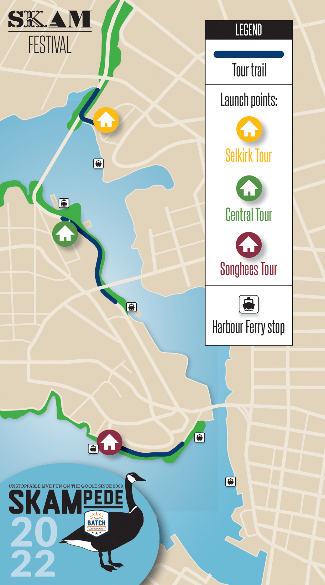

### Selkirk Tour Trail Info

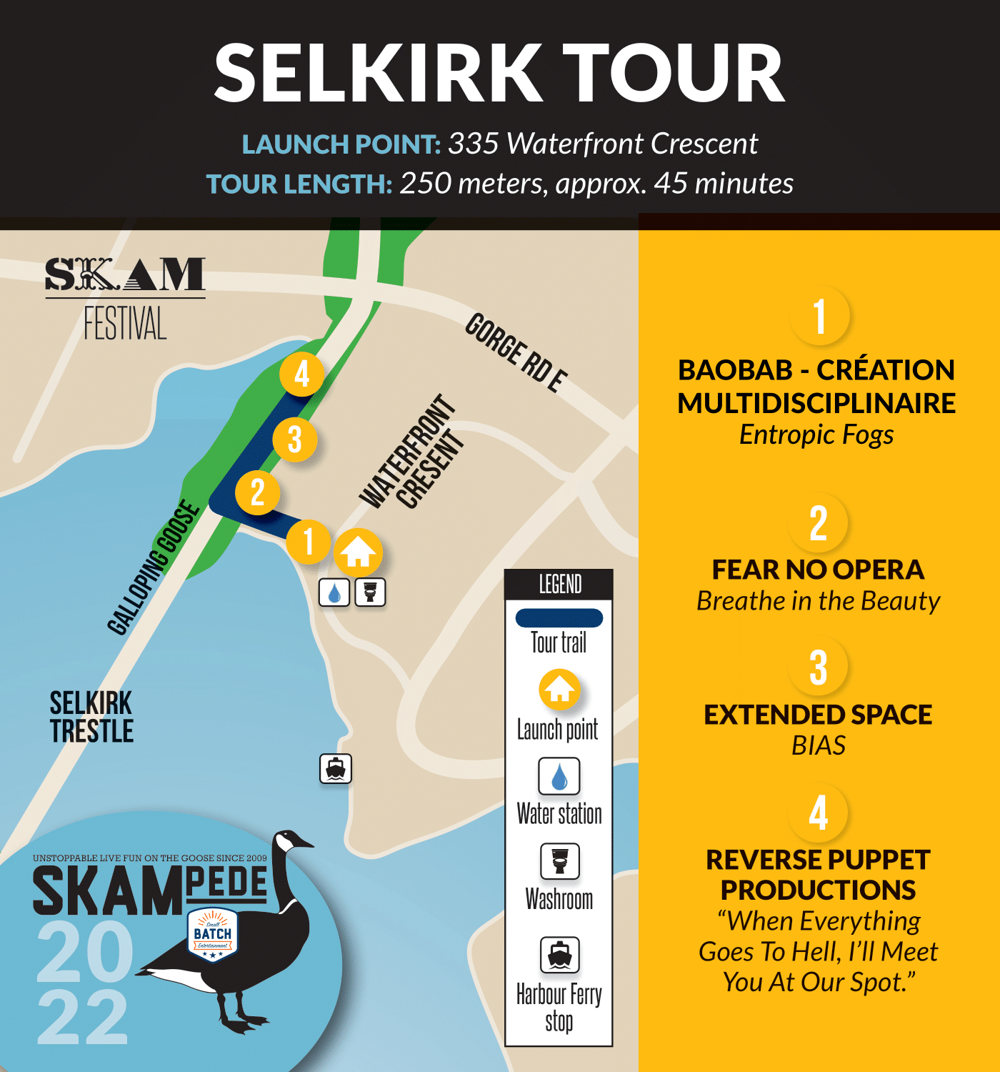

*Total distance: Approximately 250 metres (0.25 KM)*

**Launch point:** Parking lot near Selkirk Green Park (335 Waterfront Crescent). The launchpoint is on concrete.

**Washrooms:** There will be a gender neutral portable toilet at the launch point.The closest gender neutral accessible washroom is available at the HUB (Selkirk Green Park) which is close by, at 350 Waterfront Crescent.

#### Baobab - Création multidisciplinaire - *ENTROPIC FOGS*

* + Location: Flat, concrete slab close to Waterfront Crescent
  + Accessible by ramp (by the launch point)
  + One minute from the launch point

#### Fear No Opera - *Breathe in the Beauty*

* + Location: Grassy patch with a view of the Selkirk Trestle behind it; uneven grass with long weeds
  + Accessible by path (packed dirt and gravel)
  + One minute from the previous site

#### Extended Space Theatre - *BIAS*

* + Location: Benches for the performance area, across is an even grassy patch where the grass is well maintained
  + Accessible by path (concrete)
  + One minute from the previous site

#### Reverse Puppet Productions - *“When Everything Goes To Hell, I’ll Meet You At Our Spot”*

* + Location: Line of trees on the other side of the Galloping Goose trail, even packed dirt
  + Accessible by pathway (please take caution when crossing the Galloping Goose)
  + Two minutes from the previous location

### Central Tour Trail InfoA map of the Central Tour

*Total distance: Approximately 500 metres (0.5 KM) There is a paved pathway for pedestrians on the far left of the trail. The right side of the trail is only for bicycle use.*

**Launchpoint:** Parking Lot at the end of Central Spur Road. The launchpoint is on concrete.

**Washrooms:** There is one set of gendered, accessible public washrooms on the Central Tour, between Site 1 and Site 2.

#### Atomic Vaudeville- *Hello Again*

* + Location: Tiered green space by Central Spur Road, the audience area is packed dirt and gravel
  + Accessible by path (packed dirt and gravel)
  + One minute from the launchpoint.

#### Embrace Arts Foundation - *articulate*

* + Location: Paved parking lot near BC Fisheries Building
  + Accessible by textured stone pathway (please take caution when crossing the Galloping Goose)
  + Two minutes from the previous site

#### Traverse Arts Theatre - *to be them/to be us*

* + Location: Even, grassy patch underneath the Bay Street Bridge
  + Accessible by textured stone pathway (please take caution when crossing the Galloping Goose)
  + Five minutes from the previous location

#### Katie Cassidy - *funki fungi*

* + Location: Dry grassy patch; the grass is even
  + Accessible by textured stone pathway
  + Two minutes from the previous location

### Songhees Tour Trail Info

### A map of the Songhees Tour

*Total distance: Approximately 500 metres (0.5 KM)*

**Launch point:** Songhees Walkway (by Songhees Victoria Harbour Ferry Stop)

**Washrooms:** There will be a gender neutral portable toilet at the launch point.There is **no accessible washroom** on the Songhees Tour. There is a gender neutral accessible washroom at the HUB at Selkirk Green Park.

#### Tara Rajah and Kiera Radosevic - *Environmental Vibrations*

* + Location: Dry, even grassy patch
  + Three minutes from the launchpoint
  + Accessible by paved sidewalk; access to benches nearby

#### Accompany Theatre - *Deep End*

* + Location: Rocky hill just before Songhees Point
  + Three minutes from the previous location
  + Accessible by paved sidewalk; on a very small slope

#### *SNAFU - Not Enough Sunscreen in the World*

* + Location: Partial slanted hill; even grass
    - There will be blankets at the site for those who want to sit
  + Two minutes from the previous location
  + Accessible by paved sidewalk

### HUB Information

**Location:** The HUB is located at Selkirk Green Park: There will be folding chairs, tables, and tents for shade. We will also have blankets for sitting on the ground in a picnic set up. You may bring your own blanket to use.

**Washrooms:** There will be a gender neutral accessible portable toilet on HUB grounds.

**Entertainment:** The Lək̓ʷəŋən Traditional Dancers, and Reneltta Arluk (Two Indigenous performance groups).

**Concession:**

* Original and Cinnamon Sugar Pretzels - $5
* Popcorn (buttered/salted) - $3
* Candy Bags - $3
* Apples - $2
* Bananas - $2
* Sparkling Water - $2.50
* Pop - $2.50
* Ice Tea - $2.50
* Lemonade -$2.50